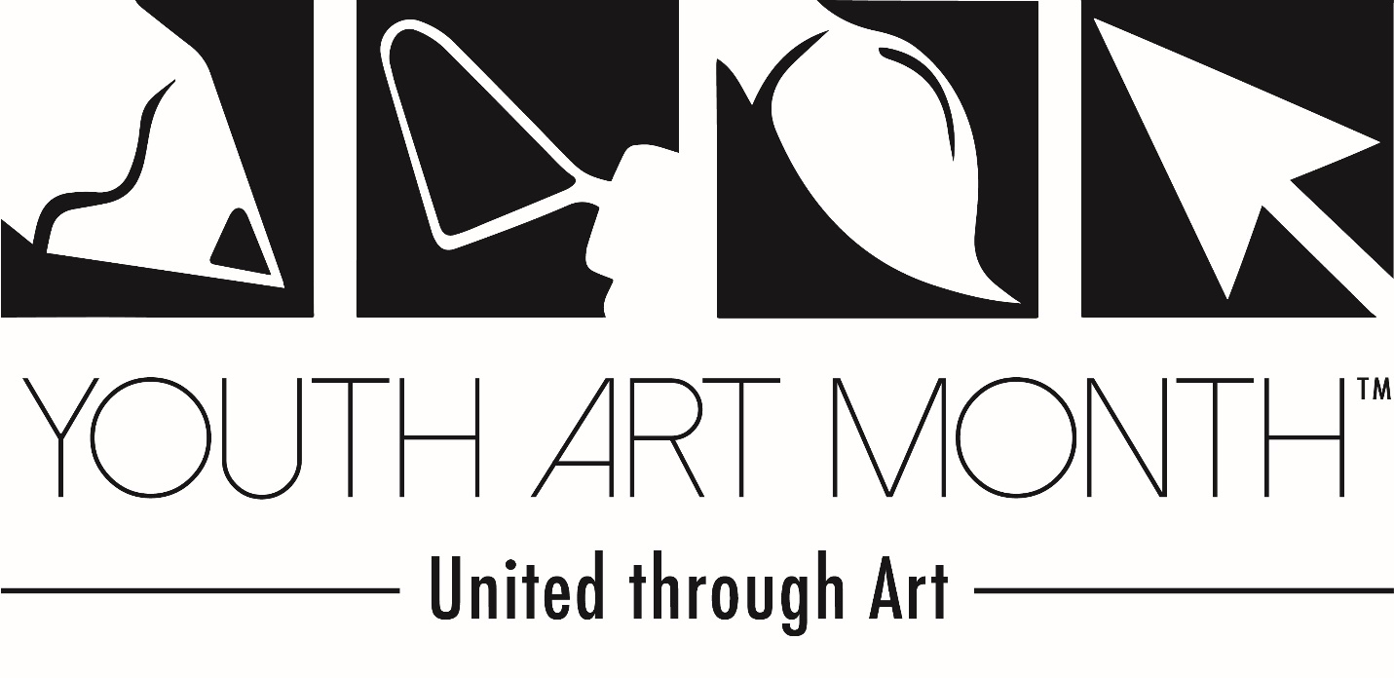
WHAT: 4th Annual Youth Art Month State Wide Student Art Exhibit
WHERE: Montana State Capital, Helena, MT
WHEN: Month of MARCH

For more information contact:
Cortni Harant
MAEA Youth Art Month Chair
Great Falls High School
1900 2nd Ave. South
Great Falls, MT 59405
406-260-6532, cell

From NAEA:

Youth Art Month is a celebration of the visual arts!

The Council for Art Education (CFAE) administers Youth Art Month. Youth Art Month encourages support for quality school art programs, and promotes art material safety. The Council for Art Education (CFAE) administers the program at the national level. The program provides a medium for recognizing skills developed through visual arts experiences unlike any other curriculum subjects, including:

- Problem solving
- Creativity
- Observation
- Communication

Art shows, special exhibits, fundraisers, and school and community activities take place annually, traditionally during March, to celebrate visual art education for grades K – 12.
TIMELINE:
Now Start collecting the best of the best of your students’ works of art, K-12
- Each teacher can send two to three 2-D pieces, pending scale & response
- Works must be mounted/matted and hangable (hot glue and string works great)
- We use Command strips on marble to hang, so works can’t be too heavy
- NO FRAMES unless YOU provide the easel
- 3-D works are encouraged, number is not as limited but please think of media when shipping

February 5th, 2017 Letter of support from the Governor will be posted on the MAEA website
- Please download, print, post and use to support your programs and local shows

February 9th, 2017 Physically mail or deliver works to Great Falls High School, Great Falls, MT

Great Falls High School
Attn: Cortni Harant, Art
1900 2nd Ave. South
Great Falls, MT 59405

Send appropriate postage to return your work in April OR pick it up at MAI

Use the excel template on the MAEA website to send label information to: cortni_harant@gfps.k12.mt.us

February 28th, 2017 Work gets installed in Helena at the State Capital with printed labels
- Podiums are borrowed from the Holter Museum in Helena for 3-D work(huge thank you)

March 1st – 28th Youth Art Month Student Exhibit on public display at the Capital

Document any local Youth Art Month activity in your community and share it for the Chair report

March 28th Show comes down and letters for all student participants are collected from the Governor’s office

April Work is returned to participating schools with the letters of appreciation from the Governor with your prepaid postage OR delivered at MAI (April 13th & 14th)

This event is made possible by the Holter Museum of Art, Great Falls Public Schools, and YOU!!!
Thank you for your hard work and dedication to keep the visual arts alive in our schools.
Make it a beautiful day.

