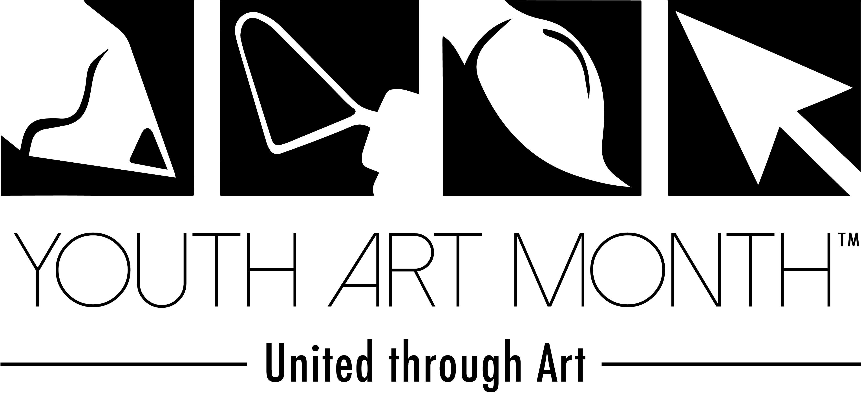
WHAT: 3rd Annual Youth Art Month State Wide Student Art Exhibit
WHERE: Montana State Capital, Helena, MT
WHEN: Month of MARCH

For more information contact:
Cortni King
MAEA Youth Art Month Chair
Great Falls High School
1900 2nd Ave. South
Great Falls, MT 59405
406-260-6532, cell

From NAEA:

Youth Art Month is a celebration of the visual arts!

The Council for Art Education (CFAE) administers Youth Art Month. Youth Art Month encourages support for quality school art programs, and promotes art material safety. The Council for Art Education (CFAE) administers the program at the national level. The program provides a medium for recognizing skills developed through visual arts experiences unlike any other curriculum subjects, including:

- Problem solving
- Creativity
- Observation
- Communication

Art shows, special exhibits, fundraisers, and school and community activities take place annually, traditionally during March, to celebrate visual art education for grades K – 12.
TIMELINE:
Now Start collecting the best of the best of your students’ works of art, K-12
- 2-D and 3-D works can be submitted
- Each teacher can send 2-3 pieces, pending scale & response
- Works must be mounted/matted and hangable (hot glue and string works great)
- We use Command strips on marble to hang, so works can’t be too heavy

February 6th, 2016 Letter of support from the Governor will be posted on the MAEA website
- Please download, print, post and use to support your programs and local shows

February 10th, 2016 Physically mail or deliver works to Great Falls High School, Great Falls, MT

Great Falls High School
Attn: Cortni King, Art
1900 2nd Ave. South
Great Falls, MT 59405

Send appropriate postage to return your work in April

Use the excel template on the MAEA website to send label information to: cortni_king@gfps.k12.mt.us

February 28th, 2016 Work gets installed in Helena at the State Capital with printed labels
- Podiums are borrowed from the Holter Museum in Helena for 3-D work(huge thank you)

March 1st – 30th Youth Art Month Student Exhibit on public display at the Capital (this is a legislative year, great exposure)

Document any local Youth Art Month activity in your community and share it for the Chair report

March 31st Show comes down and letters for all student participants are collected from the Governor’s office

April Work is returned to participating schools with the letters of appreciation from the Governor

This event is made possible by the
Holter Museum of Art,
Great Falls Public Schools,
and YOU!!!

Thank you.

